**GIT Branching**

Name – Hritik Ray

Section - C

Objective: Commit HTML, CSS & JavaScript assignments into GIT.

1. **Create a new branch ‘js-assignments’.**



1. **Switch to ‘js-assignments’ branch.**



1. **Copy all JavaScript assignments inside ‘Assignments’ folder**



1. **Commit JavaScript assignments into ‘js-assignments’ branch.**

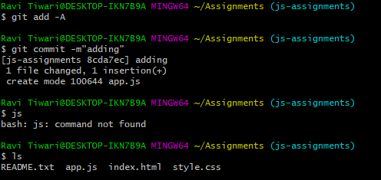

1. **Make minor changes into README.txt file on line 1 belonging to ‘js-assignments’ branch.**

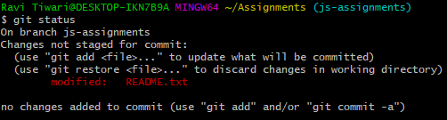

1. **Commit those changed files.**

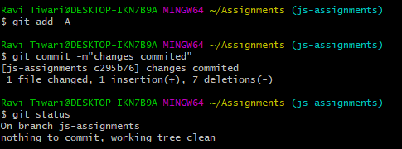

1. **Switch to master branch**



1. **Make minor changes into README.txt file on line 1 & commit those changes into master.**

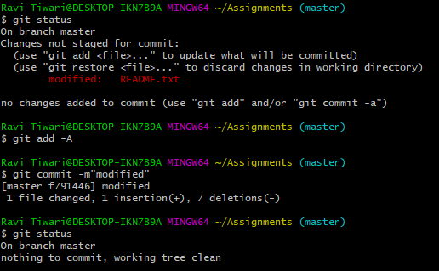

1. **Again switch to ‘js-assignments’ branch.**



1. **Make minor changes into few files belonging to ‘js-assignments’ branch.**

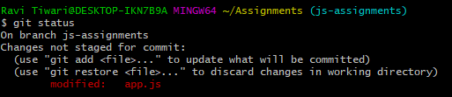

1. **Commit those changes.**

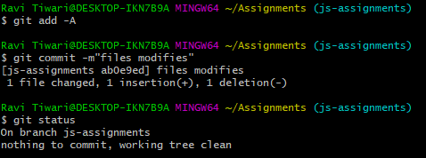

1. **Switch to master.**



1. **Merge ‘js-assignments’ branch into master. Confirm all JavaScript assignments are shown in master.**

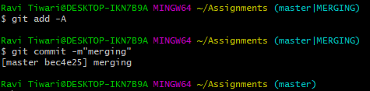

1. **Finally delete the ‘js-assignments’ branch.**

